Name : K. Hari Priya
H.T NO : 2303A51372
Date : 21-01-2026

Lab 2: Exploring Additional AI Coding Tools beyond Copilot – Gemini (Colab)
and Cursor AI
Task 1: Word Frequency from Text File
Scenario:
You are analyzing log files for keyword frequency.
Task:
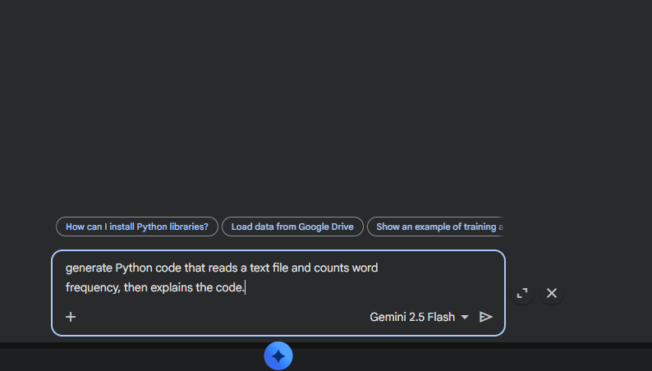
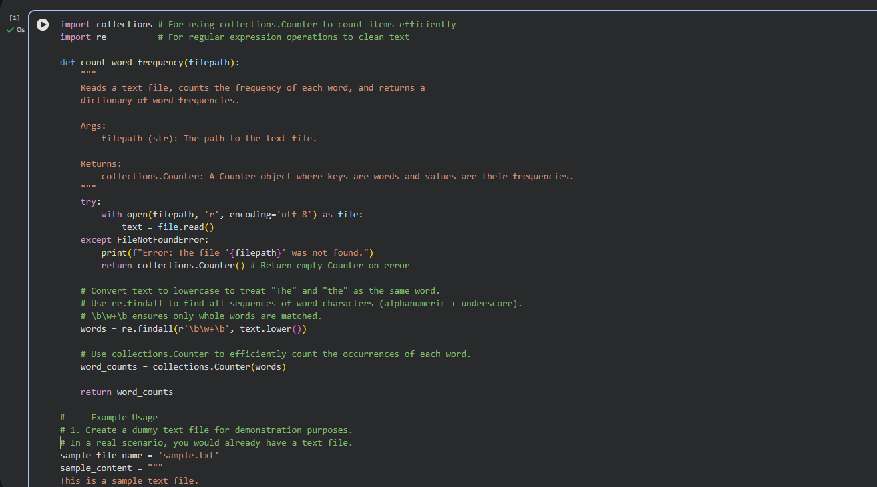
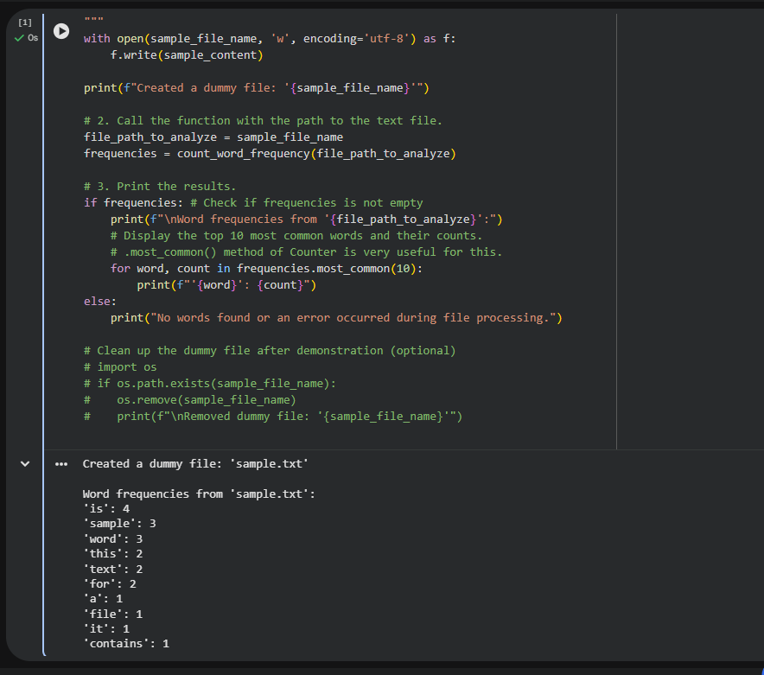
Task 2: File Operations Using Cursor AI
Scenario:
You are automating basic file operations.
Task:
Use Cursor AI to generate a program that:

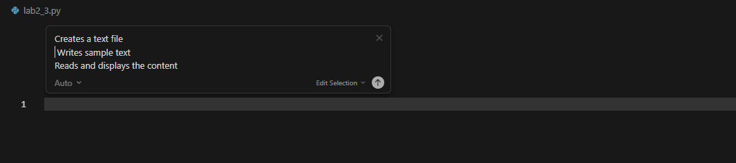
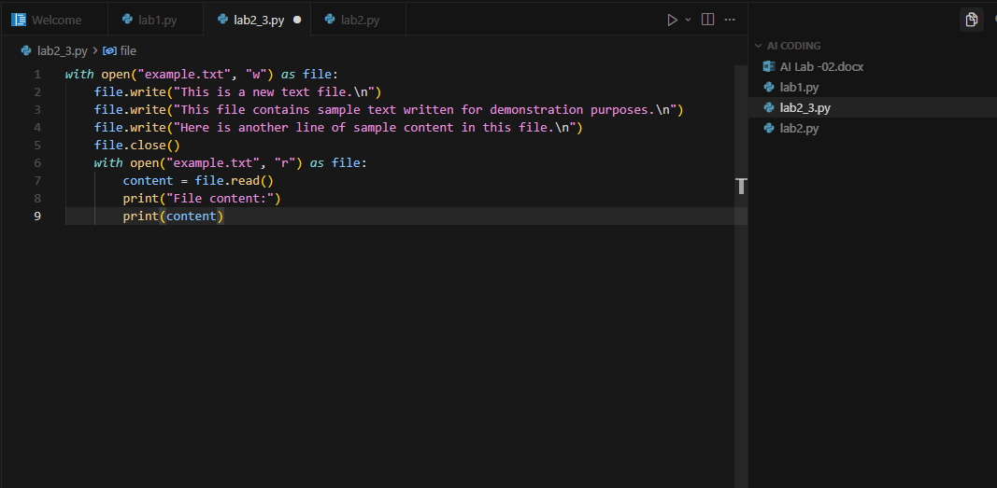
Task 3: CSV Data Analysis
Scenario:
You are processing structured data from a CSV file.
Task:
Use Gemini in Colab to read a CSV file and calculate mean, min, and max.
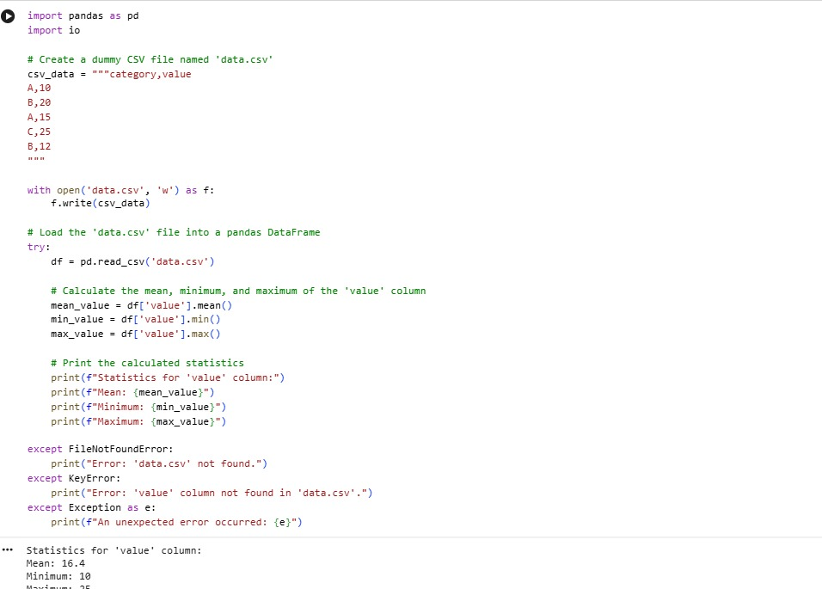
Task 4: Sorting Lists – Manual vs Built-in
Scenario:
You are reviewing algorithm choices for efficiency.
Task:
Use Gemini to generate:
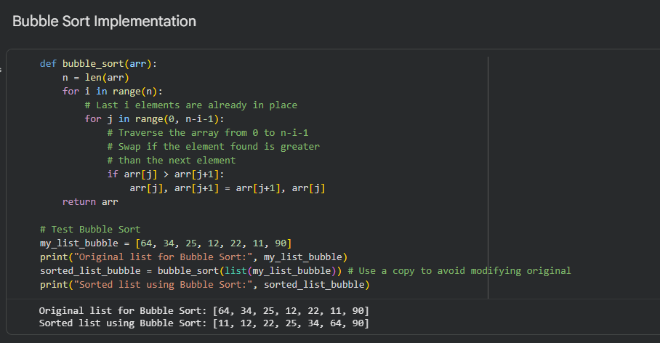
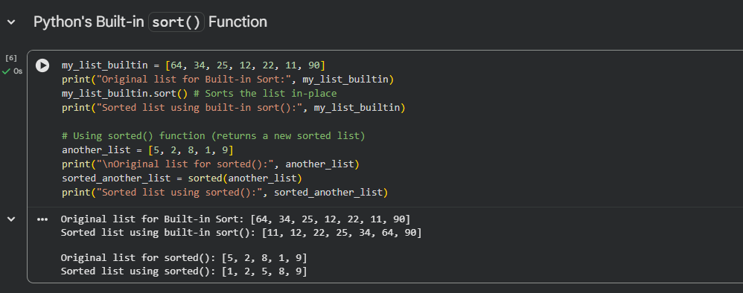
Comparison of Implementations
Bubble Sort
- How: Repeatedly swaps adjacent elements until sorted.
- Efficiency: O(n^2), very slow for large data.
- Code: Manual, long, error-prone.
Python sort()/sorted()
- How: Uses Timsort (merge + insertion hybrid).
- Efficiency: O(n\log n), fast and practical.
- Code: One simple call, clean and reliable.

